Mathematics: Units 3C and 3D
Formula sheet

Number and algebra: Calculus

Differentiation
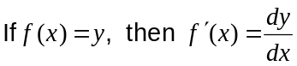
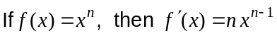
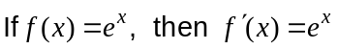

 | Function notation |  | Leibniz Notation
 |  | 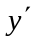
Product rule | 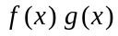 | 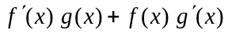 | 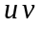 | 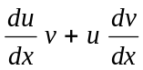
Quotient rule | 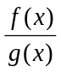 | 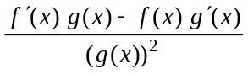 |  | 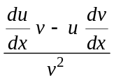
Chain rule | 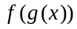 | 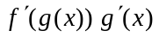 | 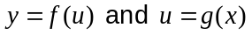 | 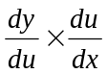

Integration
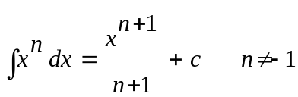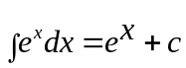

Fundamental Theorem of Calculus: 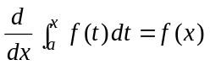and 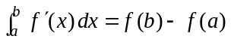

Incremental formula: 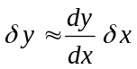

Space and measurement: Measurement

Trapezium: Area = 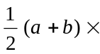height, where a and b are the lengths of the parallel sides
Prism: Volume = Area of base height
Cylinder: Total surface area = 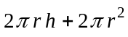 Volume = 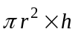
Pyramid: Volume = area of base height
Cone: Total surface area = 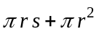, s is the slant height Volume = 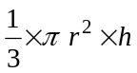
Sphere: Total surface area = 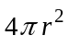 Volume = 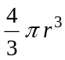

Volume of solids of revolution about the axes: 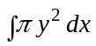 and 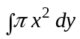

Space and measurement: Rate

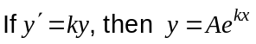

Chance and data: Quantify chance

Probability Laws
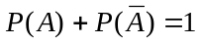

Binomial distributions: Mean: 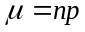 and standard deviation: 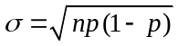

Chance and data: Represent data

Central Limit Theorem:
Mean of the sample means,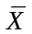, equals the population mean,
Standard deviation of the sample means equals 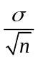
where is the population standard deviation.

Chance and data: Interpret data
Infer the mean of a population from a sample using 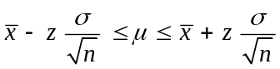
where z is the standard score for a confidence interval.

Note: Any additional formulas identified by the examination panel will be included in the body of the particular question.

